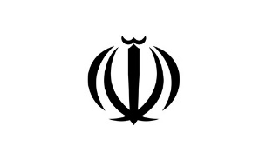

**IRAN Report**

«7»

**Details of Iranian-Cuban Covid-19 vaccine**

Head of Pasteur Institute of Iran said that Cuba is one of the few countries whose vaccine industry is very advanced and in previous years was the only country that has exchanged vaccine production technology with Iran.

He also added that the Cuban Covid-19 vaccine is compatible with the pediatric pneumonia vaccine and as part of the pneumococcal vaccine, Iran has begun a joint Covid-19 vaccine production with Cuba. It has been almost six months since the cooperation between the two countries started from the initial stages of vaccine design, animal testing and clinical trial. In human phases one and two in Cuba, it was found that the vaccine was very safe, had no side effects, and was very effective.

[https://www.isna.ir/news/99102418308](https://www.isna.ir/news/99102418308/)

**Achievements of "Citizen Diplomat" project**

Through the instrumentality of citizen diplomacy, the municipality of Isfahan intends to build a platform for the development of urban diplomacy to make cities the main lever in resolving urban issues, including poverty, air and environmental pollution, migration, infectious diseases, injustice, organized crimes, and economic crises.

Isfahan Municipality intends to use the Diplomat Citizen Initiative to provide a platform for effective communication among Iranians living abroad, including businessmen, professors, students, cultural and media activists to introduce and strengthen the position and capacities of Isfahan.

At this point, when countries are facing the tough restrictions to stamping out the coronavirus outbreak, cooperation and communication with sister cities have not been cut off. For example, there have always been interactions between Isfahan and the city of Xi'an in China; two shipments of humanitarian aid from this Chinese city were delivered to Isfahan University of Medical Sciences. Also, during the past months, a webinar was held to exchange the experience of the Coronavirus containment measures between the mayors of Freiburg and Isfahan, as well as the municipality and the University of Isfahan and the officials of St. Petersburg universities.

<https://b2n.ir/627251>

**Makran Forward Base Ship Joins Iran’s Navy Fleet**

The Iranian forward base ship Makran joined the country’s naval fleet on Tuesday, January 12, 2021, upon the order of Major General Mohammad Baqeri, the Chief of Staff of the Iranian Armed Forces. The huge ship is said to be the biggest forward base ship in the Middle East, and enjoys special support capabilities.

Makran can serve both the naval flotilla of the Iranian Army, and other Iranian cargo vessels. Admiral Hossein Khanzadi, the commander of the Iranian Navy, said in September that Makran will be able to carry six to seven helicopters.

<Https://www.asriran.com/003D3i>

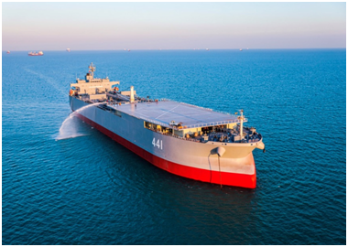

**Iran uses 'artificial intelligence' in drone drill**

Deputy Commander of Iranian Army Air Defense said that a variety of flight tactics, using artificial intelligence, was carried out for the first time in the country in a large-scale drone combat exercise.

Artificial intelligence was applied for the first time in the country in flying drones in drone combat drills, Brigadier General Elhami told Mehr News Agency. He pointed to the large-scale drone combat exercise in central desert of the country in Semnan province and added, “For many years, Army of the Islamic Republic of Iran had a very wide focus on improving the quality and use of UAVs. Relying upon the assistance of the Almighty God, we have achieved very high capabilities and capabilities in this regard.”

<https://b2n.ir/174256>

**IRGC unveils new underground missile base on Persian Gulf coast**

Iran's Islamic Revolutionary Guard Corps unveiled a new underground missile city on the Persian Gulf’s coast during a visit by IRGC Chief Commander Major General Hossein Salami and IRGC Navy Commander Rear Admiral Ali Reza Tangsiri.

Speaking at the missile city, General Salami said the IRGC Navy’s strategic missiles and their launchers are stored at the base.

“What you see today in this complex is one of several facilities containing the Guard’s naval strategic missiles, in which we see a column of missiles and their launch systems,” the IRGC chief said. “The length of these columns is kilometers and the IRGC navy possesses many of these complexes. Thank God, the Guard’s Navy has achieved the adequacy and maturity of power today.”

General Salami said these missiles are precision-guided, capable of overcoming the enemy’s electronic warfare and have a range of hundreds of kilometers as well as high destruction power.

<https://bit.ly/2LeNZsb>

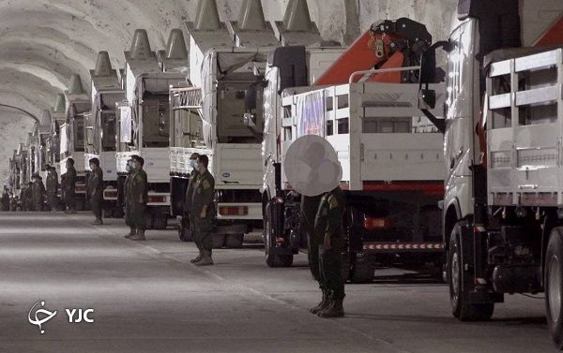

**Iranian ship arrives at Venezuelan port, data shows: Reuters**

CARACAS (Reuters) - An Iranian ship arrived at the Venezuelan port of La Guaira on Thursday, according to Refinitiv Eikon data, in what appeared to be a continuation of the commercial alliance between the two countries targeted by U.S. sanctions.

Iran has been supplying gasoline to ease fuel shortages in Venezuela caused by decay of the South American nation’s refineries and worsened by sanctions. It has also shipped food to help the government of President Nicolas Maduro.

<https://www.reuters.com/article/venezuela-iran/iranian-ship-arrives-at-venezuelan-port-data-shows-idUSL1N2JI39M>

**Iran to install 1,000 IR2m centrifuges – Salehi**

Ali Akbar Salehi, the head of Atomic Energy Organization of Iran, announced that Tehran is currently working to install 1,000 IR2m centrifuges. Salehi also said that Iran has installed at least two cascades of this type of centrifuges, both of which total more than 320 IR2m centrifuges.

<http://fna.ir/f1vwck>

**Iran can easily enrich uranium to 90% purity: AEOI spokesman**

“[Our] progress has been made in such a way that we can easily enrich uranium to any percentage, even above 40, 60 and 90 percent,” Behrouz Kamalvandi, the AEOI's Spokesman, said according to Fars News Agency.

<http://fna.ir/f1wbro>

**Iran says it will halt 20% enrichment if U.S. lifts sanctions**

Deputy Foreign Minister Abbas Araghchi has said Iran will stop enriching uranium to 20 percent purity if U.S. sanctions against the country are lifted.

Araghchi said if the sanctions are lifted and Iran can benefit from the nuclear deal, the country would return to its obligations, adding the 20 percent enrichment “can be easily and swiftly reversed.”

<http://www.isna.ir/news/99101814003>

**S. Korean delegation in Tehran to discuss Iran’s frozen funds**

Foreign Ministry spokesman Saeed Khatbizadeh has said that the South Korean delegation’s visit to Tehran is aimed at negotiating Iran’s frozen financial resources.

“The delegation’s trip was agreed upon before the seizure of the violating Korean tanker, and its main agenda is to discuss access to Iran’s financial resources in Korea,” he added.

The remarks came two days after South Korea’s Foreign Ministry spokesperson Choi Young-sam said a delegation, led by Director-General for African and Middle Eastern Affairs Koh Kyung-sok, would soon leave for Tehran to resolve the issue of the seizure of MT Hankuk Chemi tanker through negotiations.

Deputy Foreign Minister for Political Affairs Abbas Araghchi also said that Iran believes that Iran's foreign exchange resources remained blocked in Korea greatly due to a lack of political will on the part of the South Korean government, rather than the oppressive US sanctions.

The Korean official also stressed that providing Iran with an access to its foreign exchange resources in Korea is one of the priorities of the Korean government, and Seoul is determined to pursue this issue until a final solution is reached.

<https://www.isna.ir/news/99102116055/>

**FM Zarif: S. Korea should release Iran's foreign exchange resources immediately**

Iran's Foreign Minister Mohammad Javad Zarif has said that the biggest obstacle to the development of Iran-South Korea relations under the current circumstances is restrictions on Iran's foreign exchange resources by South Korean banks.

Zarif stated that the illegal action of South Korean banks has negatively affected the Iranian people's view of South Korea and has seriously damaged the image of the country among the Iranians, consequently the Iranian Parliament members emphasize their legal right to enter the issue and stress that this problem should be resolved as soon as possible.

<https://www.isna.ir/news/99102216878/>

**Seizure of Korean tanker due to technical considerations - Araghchi**

In response to a request from the Korean deputy foreign minister to help resolve the issue of the Korean tanker seizure, Deputy Foreign Minister for Political Affairs, Abbas Araghchi said that the seizure of the ship in the Persian Gulf and Iranian waters was solely due to technical considerations and environmental pollution.

Korea Foreign Ministry's spokesman Choi Young-sam said Iranian officials have assured South Korea that the ship's crew were all safe

<https://www.isna.ir/amp/99101611942/?__twitter_impression=true>

**Trump's arrest warrant issued by Iraq due to Iran's follow-up**

Referring to the Iranian Foreign Ministry's pursuit for US conviction through the UN Special Rapporteur on extrajudicial killings, Mohammad Javad Zarif said, "The place of legal prosecution of the assassination of Martyr Soleimani and his companions is the courts of Iran and Iraq."

He pointed to the statement issued by the Iraqi Supreme Judicial Council on the arrest of US President Donald Trump for the assassination of Resistance commanders, saying, "This arrest warrant has been issued with a lot of follow-up by the Ministry of Foreign Affairs and other institutions."

<https://www.isna.ir/news/99102418497/>

**Iraqi court issues arrest warrant for Trump over assassination of Gen. Soleimani, PMU deputy Cmdr.**

An Iraqi court has ordered the arrest of outgoing US President Donald Trump as part of its investigation into the assassination of top Iranian anti-terror commander Lieutenant General Qassem Soleimani and his Iraqi trench mate Abu Mahdi al-Muhandis in a US drone strike near Baghdad International Airport on January 3 last year.

The arrest warrant, issued by Baghdad's Rusafa investigation court, applies to Trump under Article 406 of the Iraqi penal code, which provides for the death penalty in all cases of premeditated murder.

<https://www.isna.ir/news/99101813733/>

**Private sector joins Tehran metro**

For the first time in the history of Tehran Metro Company, a contract for supplying 105 wagons by public-private partnership will be signed soon.

<https://www.ilna.news/fa/tiny/news-1024000>

**Iran Report is a collection of news and reports in the main media outlets of the Islamic Republic of Iran.**

**(16 January, 2021)**

**Iran’s Historical Sites: Tabriz Bazar**

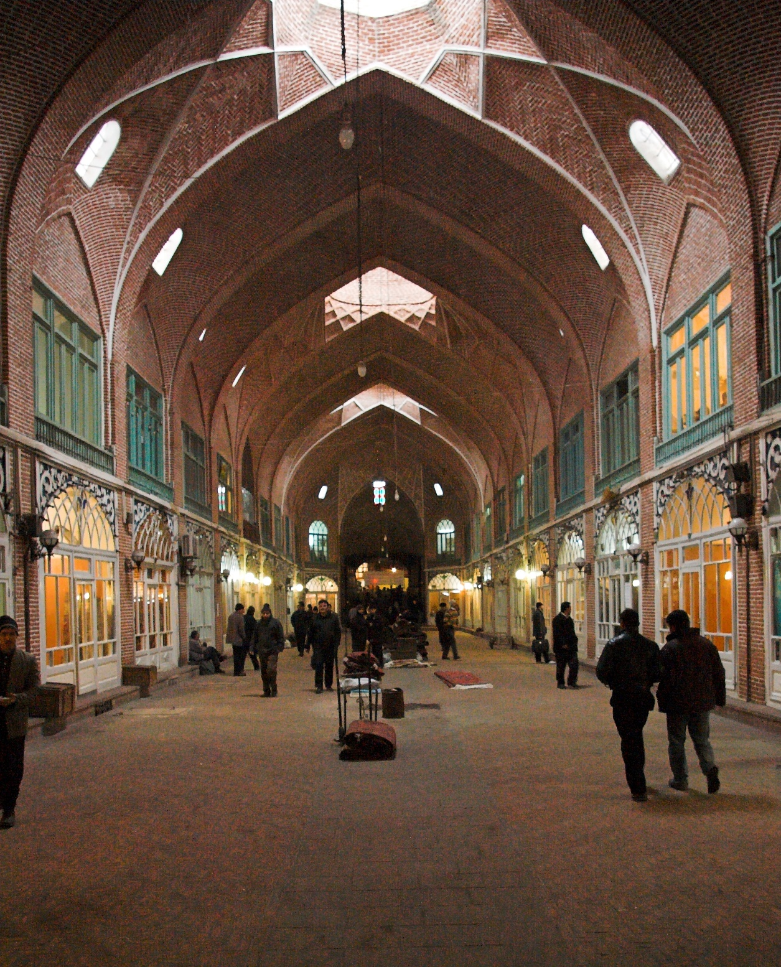

**With an area of about one square kilometer, Tabriz Bazaar is the largest covered market in the world, which is located in the city of Tabriz in Iran. It was registered in the UNESCO World Heritage List in August 2010. Tabriz Bazaar is one of the most important commercial centers on the Silk Road. The bazaar has existed on the same site since the early periods of Iranian urbanism following Islam.** **The bazaar was mentioned by the Venetian traveler Marco Polo, who claimed to have passed through it while journeying on the Silk Road.**